**Setting up your Azure DevOps Environment**

**Exercise - Set up your Azure DevOps environment**

* 4 minutes

In this section, you'll make sure that your Microsoft Azure DevOps organization is set up to complete the rest of this module.

The modules in this learning path form a progression in which you follow the Tailspin web team through its DevOps journey.

This learning path also builds on the Evolve your DevOps practices  learning path. There, you set up your Azure DevOps organization and created a task backlog on Azure Boards by using the Basic process.

**Get the Azure DevOps project**

Here, you make sure that your Azure DevOps organization is set up to complete the rest of this module. You do this by running a template that creates a project for you in Azure DevOps.

The modules in this learning path form a progression, where you follow the Tailspin web team through their DevOps journey. For learning purposes, each module has an associated Azure DevOps project.

**Run the template**

Run a template that sets up everything for you in your Azure DevOps organization.

**Click on the below link to create to create a new project using Template**

Click here : <https://azuredevopsdemogenerator.azurewebsites.net/?name=create-build-pipeline>

On the Azure DevOps Demo Generator site, perform these steps to run the template:

1. Select **Sign In** and accept the usage terms.
2. On the **Create New Project** page, select your Azure DevOps organization and enter a project name, like *Space Game - web - Pipeline*. Then select **Create Project**.

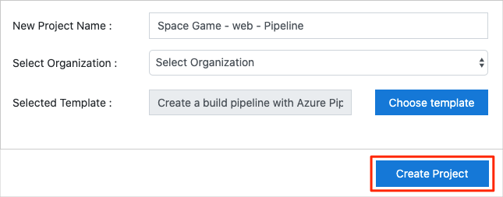

It takes a moment for the template to run.

1. Select **Navigate to project** to go to your project in Azure DevOps.

**Important**

The **Clean up your Azure DevOps environment** unit in this module provides important cleanup steps. Cleaning up helps ensure that you don't run out of free build minutes. Be sure to perform the cleanup steps even if you don't complete this module.

**Set your project's visibility**

Your fork of the *Space Game* repository on GitHub is initially public. The Azure DevOps template creates a project that's initially private.

A public GitHub repository is accessible to everyone, whereas a private repository is accessible to you and the people you share it with. In both cases, only collaborators can commit changes to a GitHub repository.

A project on Azure DevOps works the same way. Users who aren't signed in to the service have read-only access to public projects. Private projects require users to be granted access to the project and signed in to access the services.

For learning purposes, you don't need to change any of these settings right now. But for your own projects, you need to decide what visibility and access you want to provide to others. For example, if your project is open source, you might make both your GitHub repository and your Azure DevOps project public. If your project is closed source, you would likely make both your GitHub repository and your Azure DevOps project private.

**Move the work item to Doing**

In this section, you'll assign a work item to yourself on Azure Boards that relates to this module. You'll also move the work item to the **Doing** state. In practice, you and your team would create work items at the start of each sprint, or work iteration.

Assigning work in this way gives you a checklist to work from. It gives others on your team visibility into what you're working on and how much work is left. It also helps the team enforce Work in Progress limits, or WIP limits, so the team doesn't take on too much work at any given time.

Recall that the team settled on these seven top issues:

**Note**

Within an Azure DevOps organization, work items are numbered sequentially. In your project, the number that's assigned to each work item might not match what you see here.

You'll now move the first item, **Stabilize the build server** to the **Doing** column and assign yourself to the work item.

Recall that **Stabilize the build server** relates to fixing the team's existing build server, which runs on spare hardware in the office. The goal is to see if build services on Azure Pipelines can simplify build server maintenance.

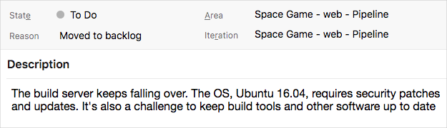

To set up the work item:

1. In Azure DevOps, navigate to **Boards** and then select **Boards** from the menu:

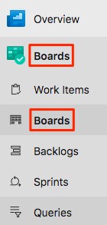

1. In the **Stabilize the build server** work item, select the down arrow at the bottom of the card. Then assign the work item to yourself.

Assigning the work item to yourself

1. Move the work item from the **To Do** column to the **Doing** column:

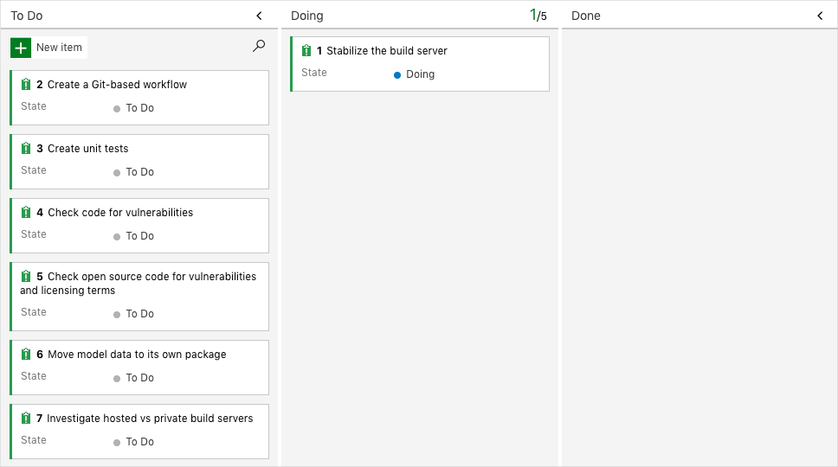

At the end of this module, you'll move the card to the **Done** column after you've completed the task.